Corning Incorporated

One Riverfront Plaza

Corning, NY 14831

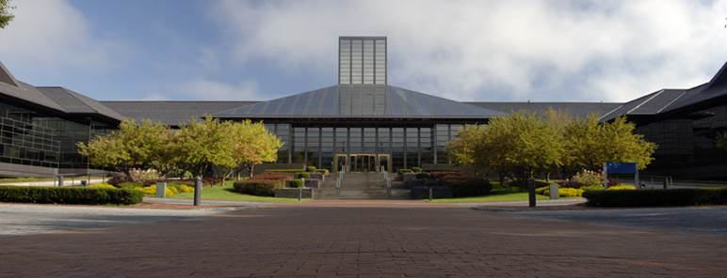

Corning New York is in the heart of the Finger Lakes Region of the Southern Tier of New York, and was voted in Rand McNally’s competition as America’s Most Fun Small town. Nearby attractions include the Corning Museum of Glass, local glass artists, hands-on glass studios, the Finger Lakes, wineries, Watkins Glen International Race Track, Cornell University and more. Additional references and details can be found by clicking on the links below:

<http://www.corningfingerlakes.com/on-the-map/places/corning?gclid=CICS3rGOo8MCFWUA7AodTkwAIQ>

<http://www.cmog.org/visit?gclid=CPStz4-Po8MCFbBm7Aod_C8ADQ>

**Nearest Airport and Distance / Travel Times:**

Elmira / Corning Regional Airport (ELM) – 11 Miles / 15 minutes by car

Greater Rochester International Airport (ROC) – 100 Miles / 1 Hour 36 minutes by car

Syracuse Hancock International Airport (SYR) – 106 Miles / 2 Hours by car

Taxi and shuttle service is available from the Elmira / Corning Regional Airport.

Air service to Corning is available nonstop through the following airports:

* Detroit Michigan (DTW) on Delta’s network with 5 flights daily
* Philadelphia Pennsylvania (PHL) on USAirways network with 2 flights daily
* Chicago (ORD) on the United network with two flights daily

Connections to additional cities and airlines are available under two hours’ drive away in Rochester, NY and Syracuse, NY.

**Driving Directions:**

Corning can be accessed via I-86 / I 390 and points west through Rochester and Jamestown, by I-99 and US-15 from the south (Washington DC / Maryland), and I-86 / US-17 from the east (New York City).

Parking is available in adjacent corporate and municipal garages.